**MOUNT ZION COLLEGE OF ENGINEERING AND TECHNOLOGY**

**LENA VILAKKU, PILIVALAM PO, TIRUMAYAM TALUK,**

**PUDUKOTTAI.**

**FILE NO :** MZCET/PN/34/2016  **Date :** 11/03/2016

WOMEN NEED RECOGNITION

GOVERNMENT MEDICAL COLLEGE DEAN,

DR.PARIMALA DEVI’S SPECIAL ADDRESS.

Mount Zion College of Engineering and Technology, Pudukottai conducted the Women’s Day celebration in a grand manner with the title ‘Enhancing insight on Reproductive Health and impact of Nutrition in Health’ organized by the students counseling cell.

Mr.Jayabarathan Chelliah, Chairman, Mount Zion Educational Insitutions presided over the function and delivered the Presidential Address. Mrs.Florence Jayabarathan, Vice – Chairperson, Mount Zion Educational Institutions delivered the Special Address. Dr.Parimala Devi, Dean-Cum-Special Officer, Government Medical College , Pudukottai delivered the Chief Guest’s Address. She dealt in detail regarding the significance of the Women’s Day celebration and the role of a mother in nurturing a child. She explained neatly about a girl child attaining puberty and how she should take care of herself eradicating unnecessary fears and the necessity of health and heigene. She highlighted the need for drinking more water which would keep the body energetic throughout the day. Professor (Mrs) Jasmine Sheela, Principal, Mount Zion College of Nursing gave a lecture on the “Impact of Nutrition in Adolescent Health”. She said that India is in transition. India has a fast growing economy but it’s poverty level is high. The Stages of a girl child can be classified as Early adolescence. Middle adolescence and Late adolescence. Care should be taken regarding nutrition during adolescence. She explained about the factors which influence adolescent food choice. A healthy diet is important for teenagers. Youth should take spinach and greens which are of nutritious value. There is good cholesterol and bad cholesterol. Vitamin ”A” rich food is essential for youth and they should take carrot and food containing Folic acid and Omega 3 fatty acids. Food stuffs rich with Vitamin “C” and Fibre rich vegetables, chamomile tea is also good for health. Youth should avoid taking too much of sugar. This sort of food habit will surely help to raise a healthy future generation.

Professor Jayson, Director, Mount Zion College of Engineering and Technology in his felicitations pointed out that in Russia Women’s Day is a holiday. He said that 30% women are getting increments compared to men and women occupy high posts in society.

College Principal, Dr.Balamurugan, in his felicitations highlighted that 56% women are working in various departments.

Professor. Elavarasi, Assistant Professor, CSE welcomed the gathering and Professor. Padmavathi, Assistant Professor, English proposed the Vote of Thanks.

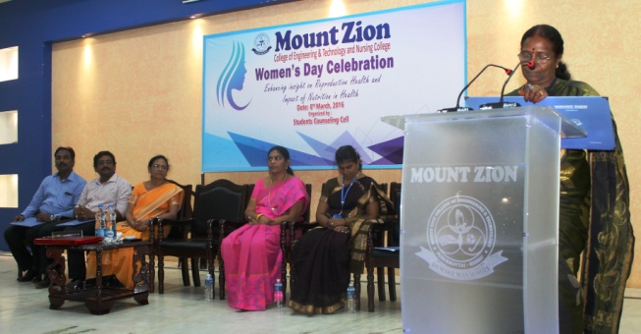

Dr.Parimaladevi , Special officer, Government Hospital, Pudukottai is addressing the Students during Women’s Day at Mount Zion College of Engineering and Technology, Pudukottai. Along with her are Mrs.Florence Jayabarathan, Vice-Chairperson, Professor.Jayson, Director and Dr.Balamurugan, Principal of Mount Zion College of Engineering and Technology and Prof.(Mrs) Jasmine Sheela, Principal, Mount Zion College of Nursing.

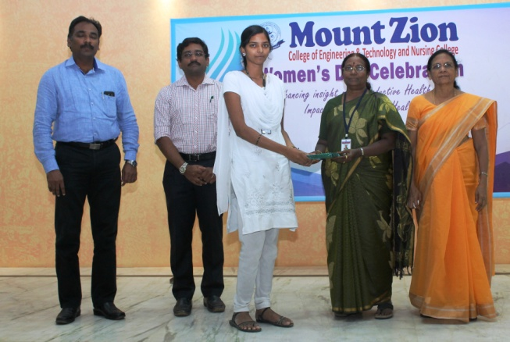

Dr.Parimaladevi , Special Officer, Government Hospital, Pudukottai is distributing a prize to the winner of the Women’s Day competitions held at Mount Zion College of Engineering and Technology, Pudukottai. Along with her are Mrs.Florence Jayabarathan, Vice-Chairperson, Prof.Jayson, Director and Dr.Balamurugan, Principal of Mount Zion College of Engineering and Technology.